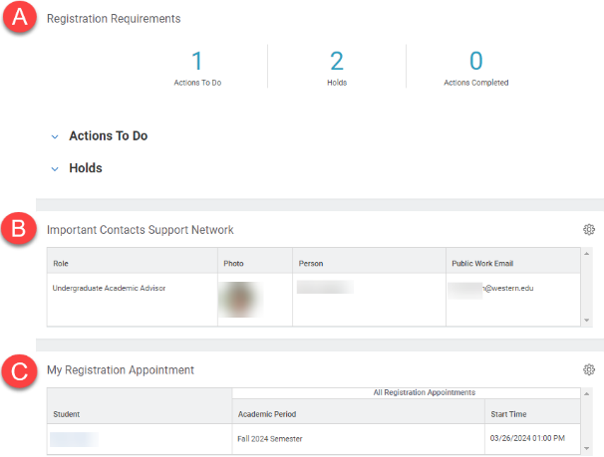
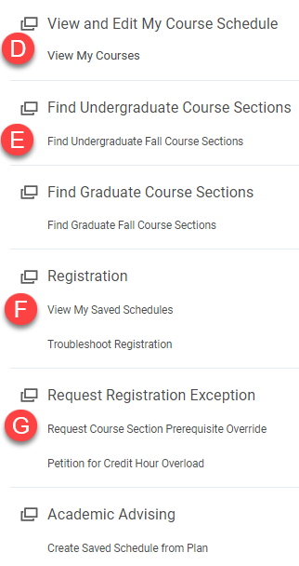
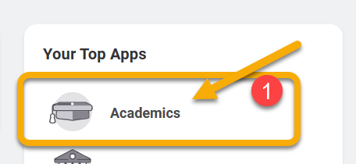
TIP: When navigating in Workday, right click links to open pages in a new tab.

INSTRUCTIONS
- To access your Academic App, log into Workday and click Academics. It will either be on Your Top Apps or you can access by going to the left hand corner of your screen.

- Scroll down to view the options in your Academics App. See the highlights below.

From your Academic App, you can register for courses, add or drop courses, view your schedule, and more.

- Registration Requirements: This window displays required Actions to Do and Holds on your account.

- Important Contacts Support Network: This window displays the name and contact information of your academic advisor.

- My Registration Appointment: You can register for classes during your registration appointment. Your appointment window begins at the date and time displayed in the Start Time column.

- View My Courses: Follow this link to see your current registration information.

- Find Undergraduate/Graduate Course Sections: Follow this link to search for up-to-date course information.

- View My Saved Schedules: Follow this link to review and edit your saved schedules.

- Request Registration Exception: Follow the links under this heading to request a prerequisite override or to petition for credit hour overload.

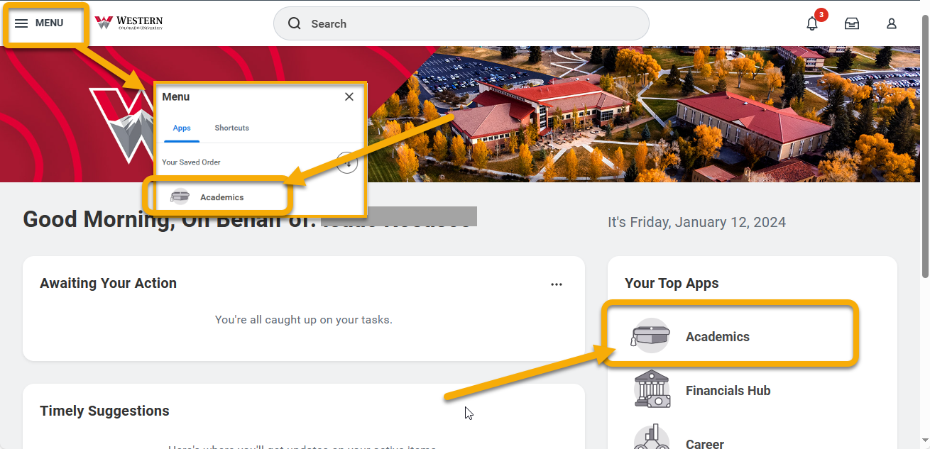
Use this guide for a quick overview of the most common features in the Academics app in Workday.
The Academic App is the hub for your academic information. From this location, you can create a saved schedule, register for courses, add, drop, or swap courses, review your academic progress (including GPA and credit hours), find your academic advisor contact information, and much more.

Instructions
- To access your Academic App, log into Workday and click Academics from the right-hand menu or the upper left menu.

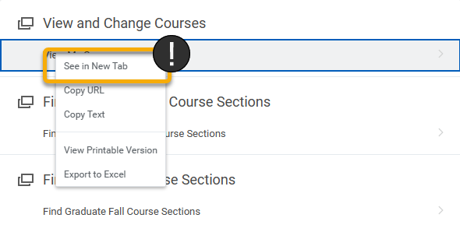
TIP: To move around Workday more easily, right click links and open in new tab. When finished with the tab, simply close and return to the previous window.

- On the Academics homepage, you will find three windows and a right-side menu. See descriptions below.

- Registration Requirements: This window displays required Actions to Do and Holds on your account. It is important to review and resolve these items to prevent interruptions in registration.

- Important Contacts Support Network: This window displays the name and contact information of your academic advisor.

- My Registration Appointment: You can register for classes during your registration appointment. Your appointment window begins at the date and time displayed in the Start Time column.

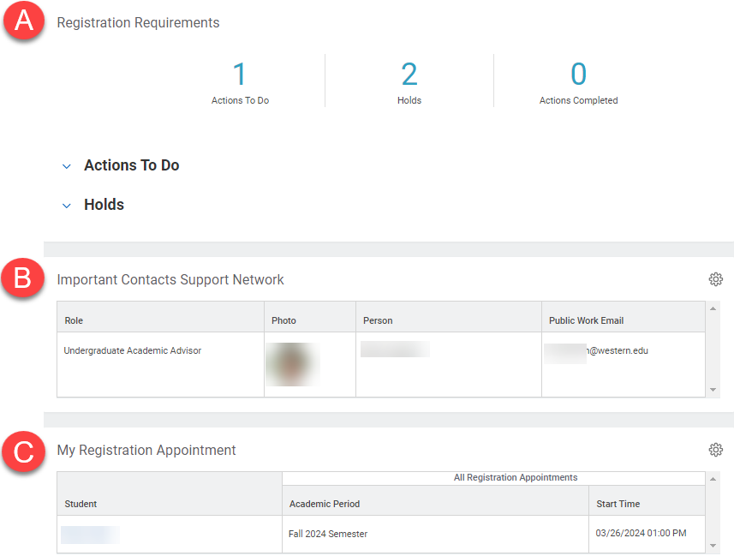

- From the right-hand menu, you can see your current classes and complete all steps related to registration, including requesting overrides and reviewing saved schedules. See below for more information.

- View My Courses: Follow this link to see your current registration information, including your enrolled courses in the current and upcoming academic periods.

- Find Undergraduate/Graduate Course Sections: Follow this link to search for up-to-date course information.

- View My Saved Schedules: Follow this link to review and edit your saved schedules.

- Request Registration Exception: Follow the links under this heading to request a prerequisite override or to petition for credit hour overload.

